
Finding Name: Open Redirect.
Name | Team | Role | Project | Quality Assurance | Is this a re-tested Finding?
Shamail Haider | SCR | Senior Team Member | Ontrack | Jaspriya Kaur and Payas Paul

Was this Finding Successful?
Yes
Finding Description
An open redirect vulnerability is a sort of security problem that occurs when a web application sends visitors to a specific URL without sufficient validation. Attackers can use this vulnerability to reroute visitors to malicious websites, phishing pages, and other dangerous material.
Risk Rating
Impact: Significant
Likelihood: Moderate
Impact values
Very Minor | Minor | Significant | Major | Severe
Risk that holds little to no impact. Will not cause damage and regular activity can continue. | Risk that holds minor form of impact, but not significant enough to be of threat. Can cause some damage but not enough to impede regular activity. | Risk that holds enough impact to be somewhat of a threat. Will cause damage that can impede regular activity but will be able to run normally. | Risk that holds major impact to be of threat. Will cause damage that will impede regular activity and will not be able to run normally. | Risk that holds severe impact and is a threat. Will cause critical damage that can cease activity to be run.

Likelihood
Rare | Unlikely | Moderate | High | Certain
Event may occur and/or if it did, it happens in specific circumstances. | Event could occur occasionally and/or could happen (at some point) | Event may occur and/or happens. | Event occurs at times and/or probably happens a lot. | Event is occurring now and/or happens frequently.

Business Impact
Affected Assets
doubtfire-web\src\app\sessions\states\sign-in\sign-in.component.ts
Evidence
Step 1.
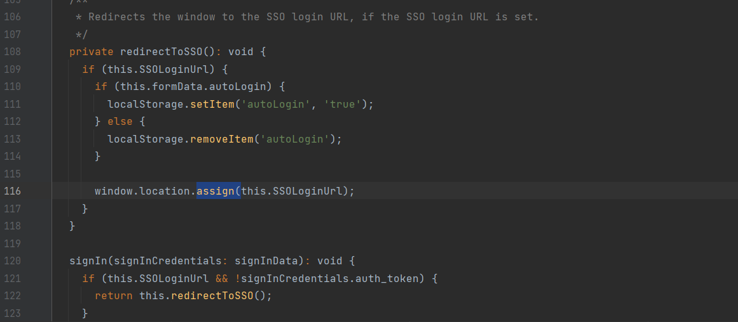

Remediation Advice
Encode provided URLs to prevent injection of malicious code.
try {
chrome.extension.getBackgroundPage().tgs.setViewGlobals(global, 'options');
} catch (e) {
window.setTimeout(() => window.location.reload(), 1000);

References
Snyk CWE-601: URL Redirection to Untrusted Site ('Open Redirect')
OWASP Cheat Sheet Series, https://cheatsheetseries.owasp.org/cheatsheets/Unvalidated_Redirects_and_Forwards_Cheat_Sheet.html

Contact Details
Shamail Haider
S222408241@deakin.edu.au

Pentest Leader Feedback.
The lead will provide feedback to enact on.

